DEPOSIT
#{{Invoice_Number}}

Balance Due
{{Amount_Due}}

{{Brand_Name}}
{{Brand_Address_Line_1}}
{{Brand_Address_Line_2}} | Invoice Date: | {{Invoice_Date}}
{{City}}, {{State}} {{Pin_Code}} | Terms: | 15 days
{{Phone}},{{Email}} | Due Date: | {{Due_Date}}

Description |  | Amount
Advance Deposit for cashback |  | {{Deposit_Amount}}
 | Sub Total | {{Sub_Total}}
 | Amount Due | {{Amount_Due}}

Note: TDS is not applicable as this is an advance deposit that will be used for cashback reimbursement.

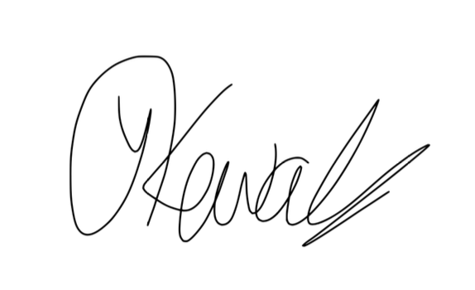
Yash Kewalramani
Authorized Signatory
🏦 Bank Transfer Details
Name: SUPERBUZZ MARKETING TECHNOLOGIES PRIVATE LIMITED
Bank: Kotak Mahindra Bank
Branch: KORAMANGALA BANGALORE MUNIREDDY SCHOOL
Account Number: 3450653482
IFSC Code: KKBK0008079
PAN: ABOCS6112R
GSTIN: 29ABOCS6112R1ZG

📲 UPI / QR Payment
You may also scan the QR code below to make the payment via UPI:
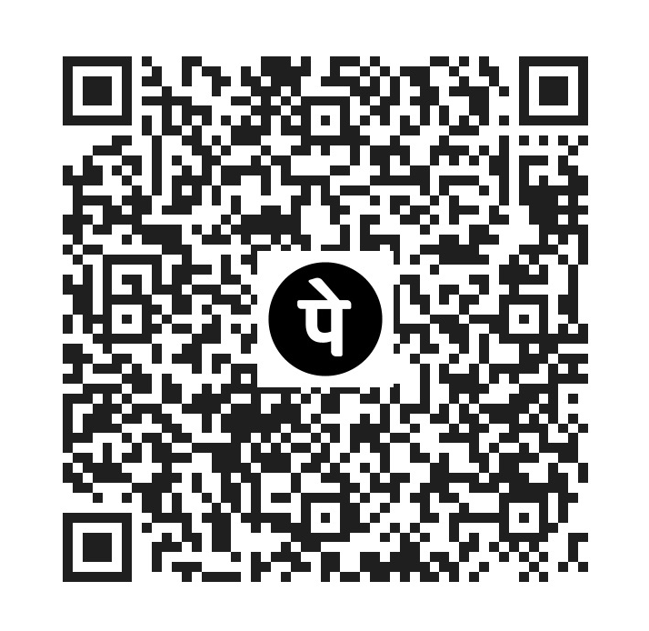
UPI ID: cherryapp@axl

